**DOCUMENTATION- BACK-END PORTAL**

Create users- right now there are 3 roles- super admin, partner admin and partner.

Super admin has access to all the functionalities. Partner admin only has access to his own products and same for partner.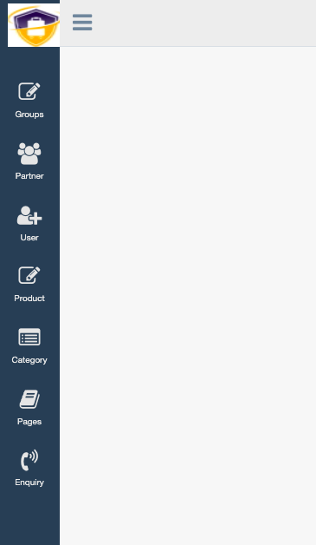

Credentials-

Super admin credentials-

anurag@segelindia.com

anurag@123

The super admin can edit and delete the group also.

The super admin can Create partners just like partner admin.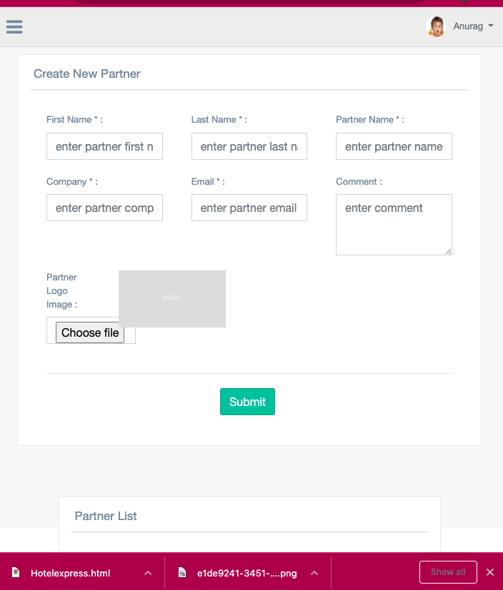 Here provision is given to add a logo also.

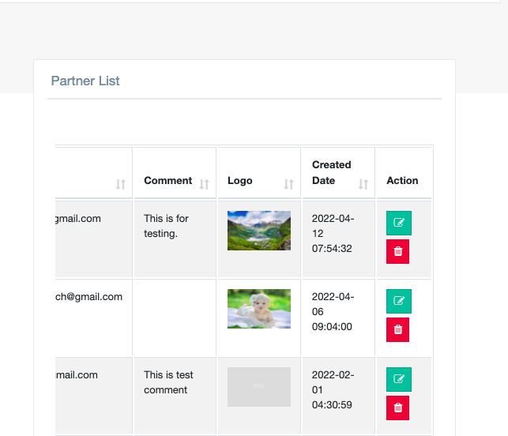

Partner admin cannot edit and delete data for other partners. Only for his own partner he can see products. Super admin can do it for all.

create user- super admin can Create other super admin/ partner admin/Partner. generate new will generate a new password every time. Unique e-mail is required for it.

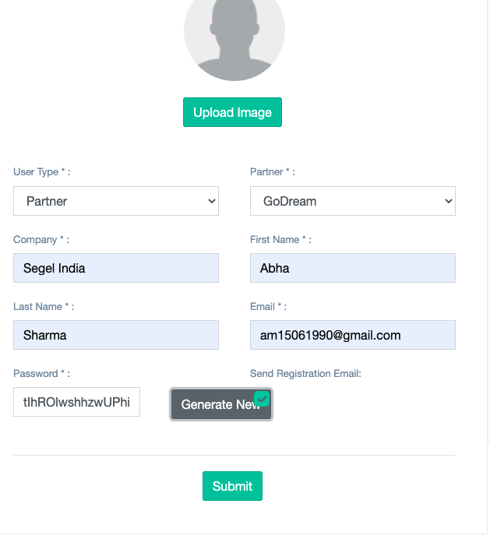

We can also create a category- The super admin can edit/delete the category as well.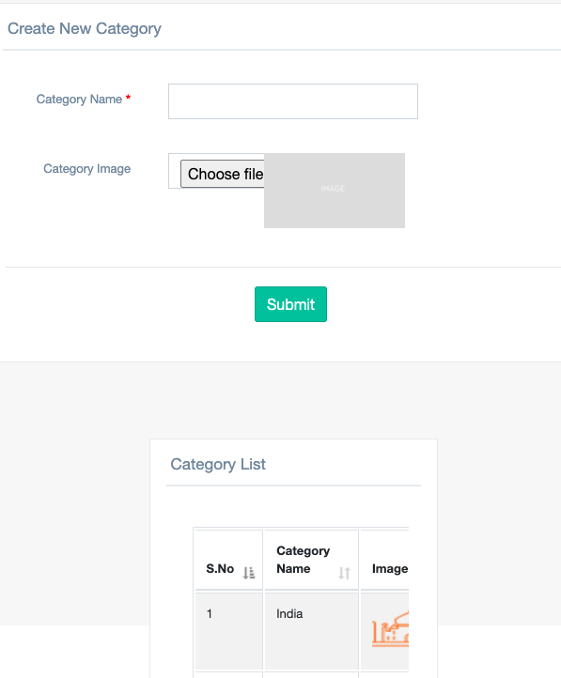

Partner admin credentials-

neelam@gmail.com

qDgntkIifgNFNiSH

Pages- about us page data can be added and previewed. It can also be deleted and edited.

Enquiry list- it stores the list of enquiries made by the users from front-end.

Partner admin can only create and edit the product He cannot delete it but make it active/inactive. Delete permanently can be done by super admin only.

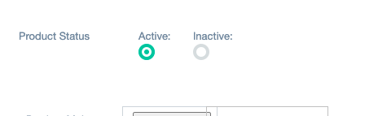

Currency comes from the database. SQL provided by client. Also meal plan. the SQL is provided by client. 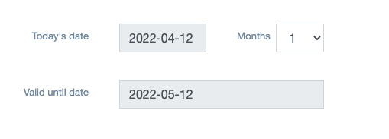

The concept of date is also dynamic. it actually adds the number of months in today’s date to find valid_until date so it is changing every day.

Description is long description. we have another field called small description. Description is shown as bullet points on the front-end. ‘.’ is the delimiter.

You can add the main banner image in Product Main Image * and gallery images. There is no check on the number of images that can be uploaded. The resolution of the images is which is standard throughout the app.

We show active product list and inactive product list to the partner admins.

partner and partner admins will see the template products.

Partner credentials

[am15111990@gmail.com](mailto:am15111990@gmail.com). , CFTvguMzieFgBXSP

Here we can just not edit the partner details also which the partner admin can do. He can only Create the products and view it.